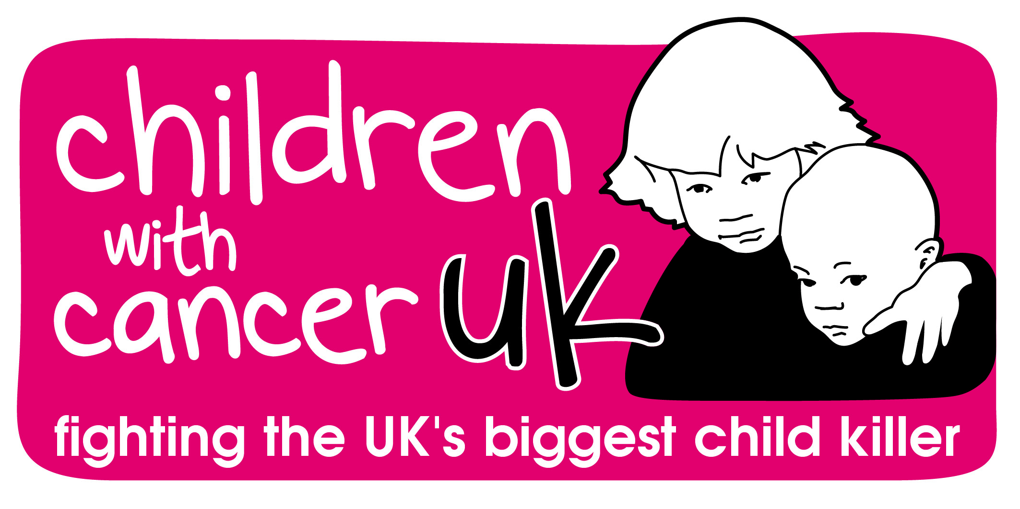
Children with Cancer UK

Job Title: Corporate Partnerships Coordinator
Salary: £25,000
Contract: Permanent
Hours: Full-time, 35 hours per week
Reporting to: Senior Manager Sports, Community & Corporate Partnerships

Job Summary

The Corporate Partnerships Coordinator will be responsible for assisting with the development of the Corporate Partnerships Programme and for the management of corporate partnerships whilst assisting the Managers in their administrative tasks. The post holder will be responsible for managing a portfolio of corporate partnerships and will provide a high standard of stewardship for donors and build strong links with external contacts at a variety of levels.

The strategic aim of the Corporate Partnerships team is to treble fundraising income by 2020.

As well as having excellent administrative and project management skills the candidate will need to be able to put in place robust, cultivation plans and monitoring and evaluation processes for all relationships, maximising opportunities. These plans shall be presented in line with budget expectation and will consider both income and expenditure to maximise the lifetime value of each Corporate Partnership.

The role demands a highly personable individual who is well organised and takes a thorough, methodical approach to their work.

Background information

Children with Cancer UK was founded after Paul O’Gorman was lost to leukaemia in February 1987 - he was 14 years old. Nine months later cancer also claimed Paul’s sister, Jean. In November 1987, Paul’s parents met Diana, Princess of Wales, who personally helped start the charity. What began as a small memorial charity is now the leading national charity dedicated to the fight against all childhood cancers.

Corporate Fundraising

  - To provide a high level of support and relationship management to corporate partnerships of the charity

  - To manage a variety of accounts effectively and efficiently

  - Develop partnerships, introducing exciting fundraising plans that will help maximise income

  - Develop fundraising concepts and materials for use across corporate fundraising activity. Prepare and deliver presentations to corporate partners as well as their employees

  - Ensure all materials delivered to Corporate Partnerships are compliant with Children with Cancer UK’s brand guidelines

  - Measure success and impact of the partnerships through agreed evaluation methods; with the aim of motivating existing partners and for use in helping to secure new partnerships

  - Identify and respond to new opportunities within each account and deliver on all programs of activities and agreed objectives

  - Support the administration requirements of the Corporate Partnerships team

  - Liaise with internal teams at Children with Cancer UK to ensure that partner requirements are met in supporting employee fundraising and volunteering opportunities

  - Successfully engage with a range of stake holders, building strong relationships to support the development of partnerships

  - Support others in the Fundraising team to deliver the strategy they are leading on

- Development

  - Identify appropriate and cost effective training and articulate the key benefits of attendance for personal development

  - Contribute to the charity’s positive culture and working environment so that the fundraising function continues to flourish

- Other key responsibilities

  - Develop excellent working relationships across Children with Cancer UK teams

  - Develop and maintain your knowledge of the charity sector and fundraising environment in order to keep up to date with changes

  - Administratively self-supporting

  - Undertake any other duties that are relevant to the job requested by the line manager
Personal Specification

 | Essential | Desirable
Skills | - Experience of managing a variety of corporate partnerships  - Excellent project management skills  - Strong networking and relationship building skills  - Articulate with persuasive and engaging verbal communication skills  - Strong numeracy skills  - Excellent written and verbal communication skills particularly in relation to writing proposals and presentations  - Attention to detail  - Time management skills, including prioritisation  - Ability to liaise and engage with key organisational stakeholders  - Skilled at developing and maintaining working relationships
Experience | - Strong administrative mind with the ability to organise and ensure administrative requirements of the department are met.  - Experience of relationship management and partnership development  - Experience of dealing with senior-level contacts both internally and externally  - Experience of working with a CRM system  - 18 months to 2 years charity experience desirable | - Experience of using Raisers Edge
Knowledge | - Sound knowledge/understanding of the principles of Corporate Fundraising  - Understanding of the corporate sector and Corporate Social Responsibility  - Good knowledge of Microsoft office programmes, such as Outlook, Word, PowerPoint and Excel
Personal qualities | - A self-starter who is able to work independently and use their judgement to make day to day decisions without referral  - Well organised with a systematic approach  - Able to work collaboratively as part of a team and contribute to a positive working environment and culture

Please forward your application to Donna.Allsop@childrenwithcancer.org.uk

