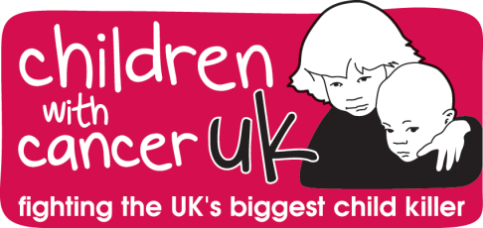
JOB PROFILE

Job Title: HR Administrator
Salary: £18,000 - £25,000 (pro-rated)
Contract: Part-time
Hours: 17.5 hours = 2.5 days per week
Reporting to: Senior Human Resources Manager

Children with Cancer UK
Children with Cancer UK was founded after Paul O’Gorman was lost to leukaemia in February 1987 – he was 14 years old. Nine months later cancer also claimed Paul’s sister, Jean. In November 1987, Paul’s parents met Diana, Princess of Wales, who personally helped start the charity. What began as a small, memorial charity is now the leading national charity dedicated to the fight against all childhood cancers.
Job Summary
Specific tasks include handling employment contracts, maintaining HR records (including HR information system, PeopleHR), recruiting, and setting up interviews for open positions in the company.
As knowledge base and experience deepens, duties will expand to include the creation of forms, templates, and other HR-related documents. The Administrator will also explain company policies and procedures to employees. Supervised by the Senior HR manager, they may also perform payroll and timekeeping functions.
Key Responsibilities
- Be the first point of contact for all HR-related queries
- Administer HR-related documentation, such as contracts of employment
- Ensure the relevant HR database is up to date, accurate and complies with legislation
- Assist in the recruitment process
- Liaise with recruitment agencies
- Set up interviews and issue relevant correspondence

Experience and Skills
 | Essential | Desirable
Skills / Ability | - Strong administration skills  - Familiarity with business software such as Microsoft Office  - A high level of confidentiality & discretion  - Excellent interpersonal and customer-facing skills  - Strong communication skills, both written and verbal  - The flexibility and willingness to learn  - Strong organisational skills  - Tact and diplomacy  - Good administrative skills  - The ability to work as part of a busy team  - The ability to work accurately, with attention to detail  - Creating and maintaining employee records  - Updating databases internally, such as sick and maternity leave  - Preparing and amending where necessary HR documents, i.e. employment contracts and recruitment guides  - Supporting the Senior HR Manager in reviewing and renewing company policies and legal compliance  - Communicating with external partners such as recruitment agencies  - Being the first point of contact for employees on any HR related queries  - Assisting with payroll by providing the department with relevant employee information, i.e. holiday and sick days taken
Knowledge | - Some understanding of Employment Law  - Experience in general HR practices  - PeopleHR system
Qualifications | Degree level in any discipline
Disposition / Personal qualities | ‘Can do’ attitude, bright, energetic and having a sense of humour!

PLEASE NOTE: this job description may be subject to change. Duties may be removed or added based on the needs of Charity.

