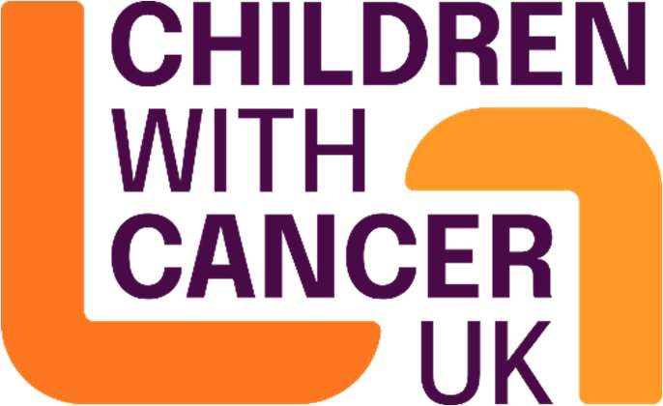

Children with Cancer UK
Candidate Pack

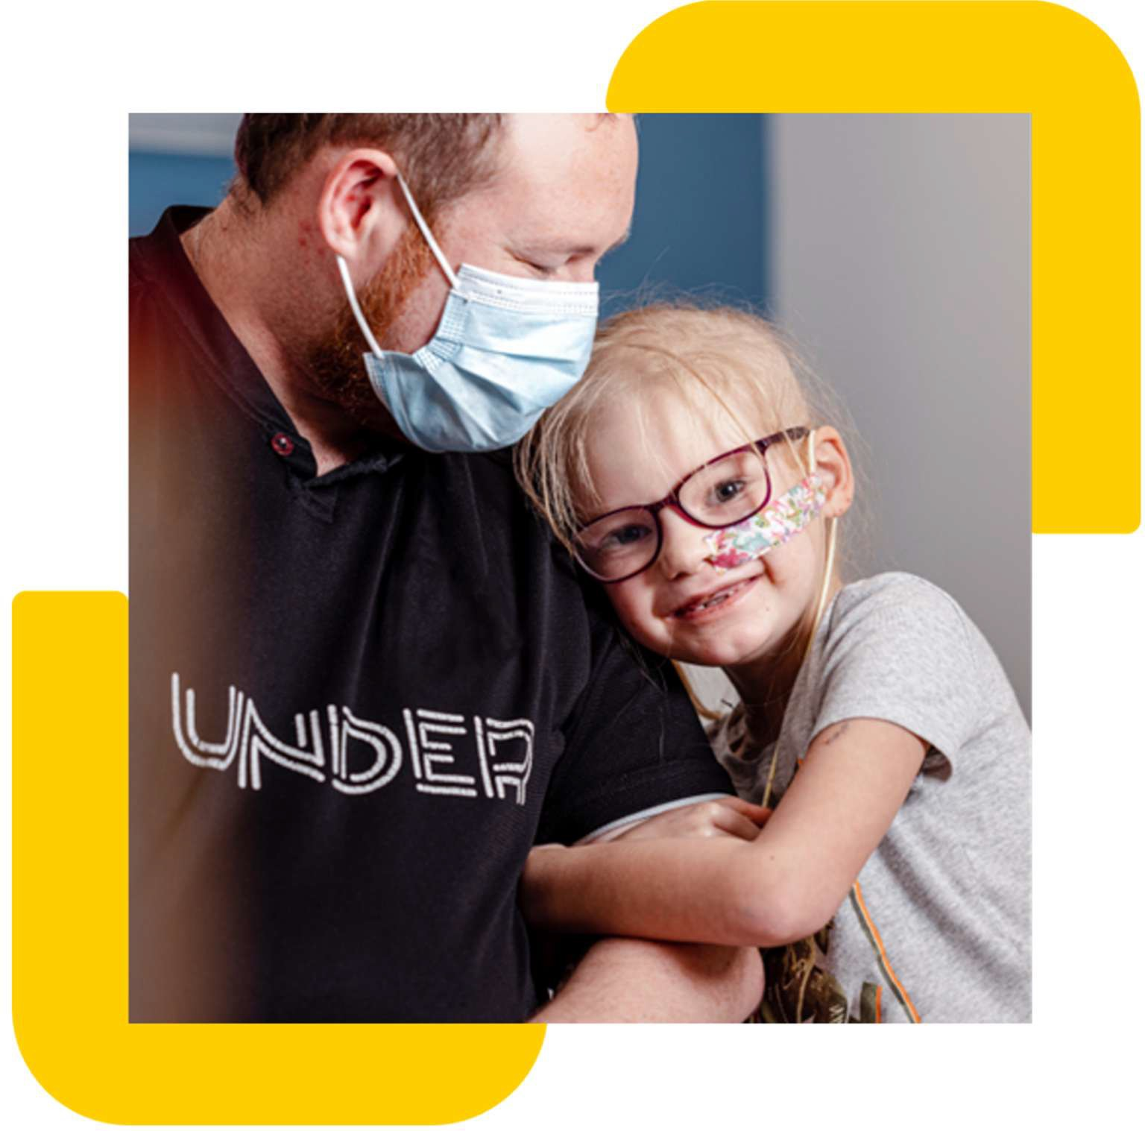

Registered Charity Number: 298405
Company limited by guarantee, Number: 4960054

Job description

Job title: Marketing and Brand Manager
Contract: Full-time, Permanent
Location: Hybrid – Minimum of 3 days a week working in the office (21-27 Lamb’s Conduit Street, London, WC1N 3NL) and 2 days working from home
Reporting to: Head of Marketing and Communications
Direct reports:
Salary range: £40,000-£45,000
Closing Date: 13th May 2026

The Role
We're looking for a strategic and creative Marketing and Brand Manager to grow awareness of Children with Cancer UK and deepen public understanding of childhood cancer and the critical need for more child-appropriate treatments.
You'll be responsible for planning, developing and delivering integrated brand marketing campaigns across owned and paid channels that reach new and existing audiences, drive engagement and inspire people to support our vital work.
This is a hands-on role for someone who combines creative thinking with analytical rigour - using evidence, insight and campaign evaluation to continuously improve performance and maximise impact. You'll manage and or work on key marketing moments (including Childhood Cancer Awareness Month, Christmas, London Marathon and more) and work collaboratively with colleagues across Digital, PR, Fundraising, Special Events and external agencies to deliver campaigns that resonate and drive results.

Children With Cancer UK
At Children with Cancer UK, our vision is a world where every child and young person survives cancer. Every day, 10 children are diagnosed with cancer in the UK, 2 terminally. Of the 8 who survive, 5 will suffer long-term effects of their treatment. We fund vital research and provide support to families affected by childhood cancer.
We are the leading childhood cancer charity in the UK, supporting families and childhood cancer research since 1988. Over the last 35 years, we've developed kinder treatments, improved public and scientific understanding of childhood cancer and raised over £300 million.

What You'll Be Doing

Strategic brand marketing
- Delivery strategic marketing and communications activity to build the charity's brand awareness and grow large audiences of supporters
- Develop and plan creative, evidence-led integrated marketing campaigns across paid and owned channels
- Manage and or support key campaign and or engagement communications moments
- Support the creative development of the charity's marketing communications activities
- Develop, brief and create engaging, audience-led branded content across a range of media and channels
- Work closely with the Digital, PR and external agencies to deliver integrated marketing campaigns that drive awareness and engagement
- Ensure cost-effective delivery of campaigns and optimise spend based on performance data
- Deputise for the Head of Marketing and Communications when required

Brand management and consistency
- Lead on the application of brand guidelines across the charity, including commissioning branded templates where needed
- Work closely with colleagues to embed the brand with internal teams, partners, suppliers and key stakeholders
- Maintain a consistent tone of voice and personality for Children with Cancer UK's brand, demonstrating best practice across the organisation
- Be part of the approvals process for teams producing branded materials across the charity
- Build strong working relationships with and proactively manage our creative and strategic agencies

Insight, evidence and evaluation
- Use audience research, insight and data to inform campaign development and creative decisions
- Track, analyse and report on campaign performance to review the effectiveness of all marketing activity
- Apply learnings from monitoring and evaluation to continuously improve future campaigns
- Project manage audience marketing research activities to deepen understanding of our supporters and potential audiences
- Use performance data to demonstrate impact and inform strategic planning

Campaign integration and collaboration
- Work strategically with colleagues across PR and Media, Digital, Fundraising, Special Events and Research teams to ensure marketing campaigns are fully integrated and mutually reinforcing
- Collaborate with the PR and Media Manager to align brand campaigns with media activity and human-interest storytelling
- Support fundraising campaigns by developing compelling marketing activations that drive supporter engagement and action
- Develop and embed processes to ensure smooth functioning of brand-led activities and content creation across multiple channels

Ambassador and partnership support
- Work with high-profile ambassadors and celebrity supporters to amplify brand campaigns and raise our profile
- Develop creative briefs and content that leverage ambassador relationships to extend campaign reach
- Support partnership marketing activities that strengthen brand awareness

About You

Essential skills and experience
- Demonstrable experience in a marketing and or brand management role
- Strong knowledge and experience of developing and delivering effective integrated marketing campaigns across multiple channels
- Experience working with both paid and owned channels (social media, website, email, content marketing, paid advertising)
- Experience working with external creative or strategic agencies
- Experience of budget management and reporting
- Track record of delivering projects on time and to tight deadlines
- Excellent creative thinking and concept development abilities
- Strong analytical skills with the ability to interpret data and translate insights into actionable strategies
- Excellent written skills for a wide range of audiences and channels
- Outstanding relationship-building and stakeholder management skills
- Strong project management skills to deliver multi-channel campaigns
- Ability to organise and prioritise a demanding workload
- Enthusiasm, initiative and a proactive approach
- Passion for creativity combined with strategic, evidence-based thinking
- Support leaders within the Marketing and Communications team in maintaining the team and directorate vision including leading by example and setting a positive culture
- Ability to deputise for the Head of Marketing and Communications when required
- Commitment to Children with Cancer UK’s purpose and values including equality and social inclusion

Desirable
- Experience in the charity, health or purpose-driven sector
- Knowledge of childhood cancer, medical research or healthcare
- Experience managing brand launches or rebrands
- Familiarity with marketing automation tools and CRM systems
- Experience working with campaign measurement frameworks and KPIs
- Understanding of digital marketing best practices and emerging trends
- Experience developing content strategies
- Knowledge of accessibility and inclusive marketing practices

Personal Qualities
- Act purposefully: Put children and families at the heart of everything you do
- Build trust: Operate with integrity and maintain brand consistency
- Create connections: Build strong, collaborative relationships across teams and with external partners
- Drive change: Bring creativity, innovation, and fresh perspectives
- Deliver results: Achieve ambitious goals while managing competing priorities and budgets
- Commitment to Children with Cancer UK's purpose and values including equality and social inclusion

Other key details
- Some evening and weekend work will be required (time off in lieu will be given)
- Occasional working away from London and spending nights away from home may be required

Why Join Us?
- Make a meaningful difference to children and families affected by cancer
- Work with a passionate, inclusive, and welcoming team
- Enjoy policies that support work-life balance
- Contribute to life-saving research and impactful campaigns

Other information

At Children with Cancer UK, we value diversity, and we are committed to creating an inclusive
culture where everyone is able to be themselves and to reach their full potential. The
statements are not intended to be construed as an exhaustive list of all duties, responsibilities and skills required for this position.

How to Apply
We operate an anonymised shortlisting process in line with our commitment to equality, diversity, and inclusion. Please submit your CV and cover letter.
If you require any reasonable adjustments during the application or interview process, please contact us at hr@childrenwithcancer.org.uk
You must be eligible to work in the UK to apply for this vacancy.

