

Children with Cancer UK
Candidate Pack

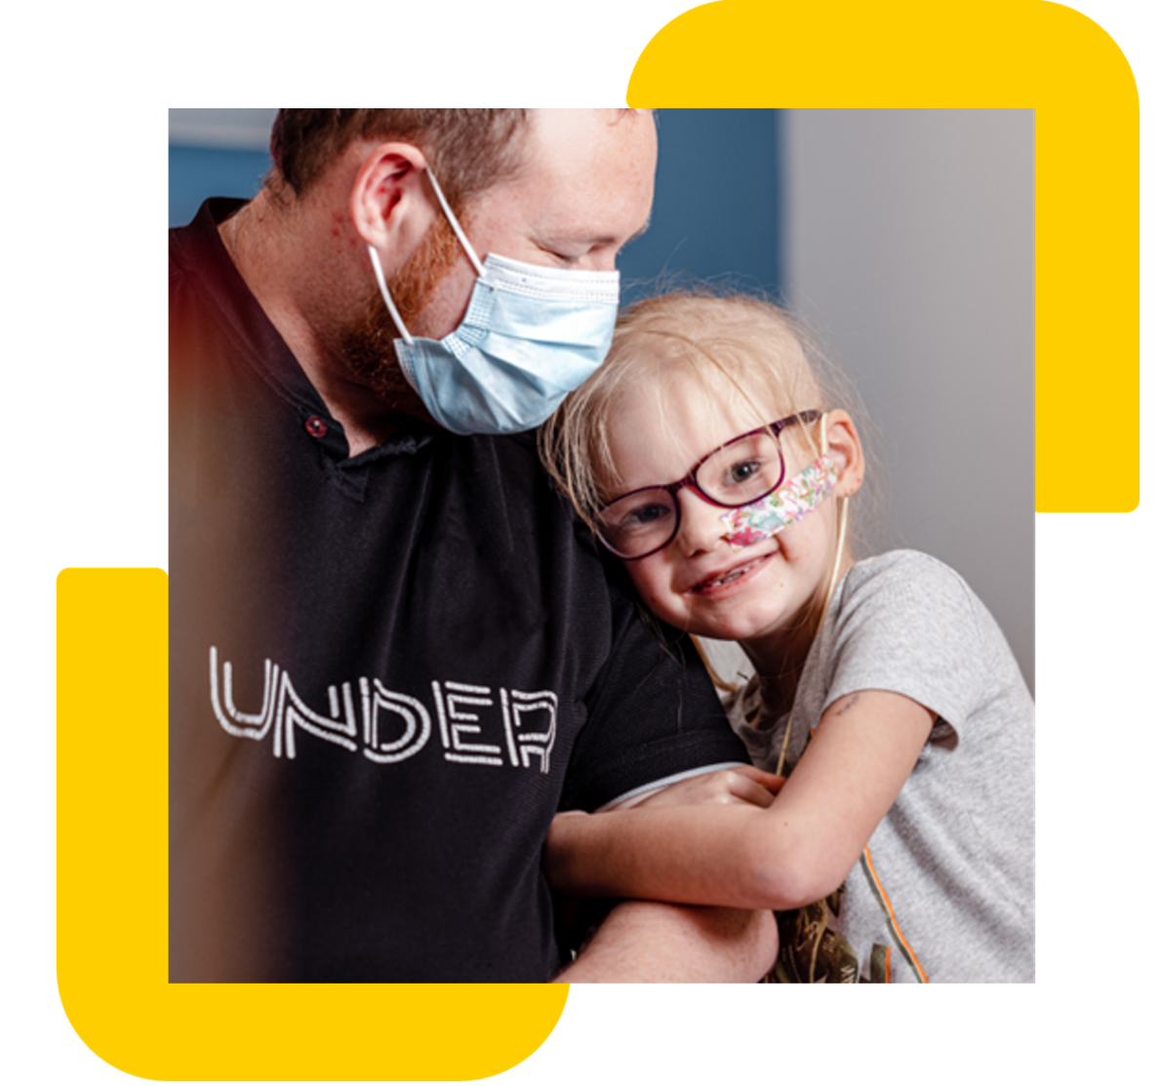

Registered Charity Number: 298405
Company limited by guarantee, Number: 4960054

Job description

Job title: Social Media Executive
Contract: Full-time, Permanent
Location: Hybrid – Minimum of 3 days a week working in the office (21-27 Lamb’s Conduit Street, London, WC1N 3NL) and 2 days working from home
Reporting to: Digital Marketing Manager
Direct reports: None
Salary range: £30,000
Closing Date: 7th May 2026

Role

We're looking for a creative, audience-obsessed Social Media Executive to grow our digital presence and create content that people can't ignore.

You'll be responsible for managing our social media channels day-to-day, building engaged communities and creating thumb-stopping content that drives awareness, engagement and action. This is a hands-on role for someone who lives and breathes social media, understands what makes content shareable and knows how to turn followers into advocates.

From crafting viral-worthy posts to capturing live moments at events, you'll be the voice of Children with Cancer UK online, building authentic connections with our community while amplifying the impact of our life-saving work.

Children with Cancer UK

At Children with Cancer UK, our vision is a world where every child and young person survives cancer. Every day, 10 children are diagnosed with cancer in the UK, 2 terminally. Of the 8 who survive, 5 will suffer long-term effects of their treatment. We fund vital research and provide support to families affected by childhood cancer.

We are the leading childhood cancer charity in the UK, supporting families and childhood cancer research since 1988. Over the last 35 years, we've developed kinder treatments, improved public and scientific understanding of childhood cancer and raised over £300 million.
Key responsibilities

Community growth and engagement
- Own day-to-day management of all social media platforms including Instagram, TikTok, Facebook, LinkedIn, X and YouTube
- Significantly grow our social media following and engagement through inspiring and shareable content
- Create content that people can't scroll past, combining emotional storytelling, research impact and calls to action
- Monitor social trends, platform updates and competitor activity to identify opportunities and keep our content fresh and relevant
- Act as the charity's social media champion, staying ahead of trends and bringing creative ideas to life
- Build and nurture engaged online communities, responding to comments, messages and mentions with authenticity and care
- Identify and engage with user-generated content, amplifying supporter stories and celebrations
- Identify and engage with influencers, advocates and supporters who can amplify our reach
- Monitor sentiment and flag issues or opportunities to relevant teams
- Recognise and nurture brand advocates and superfans
Content creation and planning
- Develop and maintain a dynamic content calendar that aligns with organisational priorities, campaigns and key moments
- Create platform-native content optimised for each channel, whether that's Reels, Stories, carousels, video, or static posts
- Collaborate with the Scientific Engagement Manager and Stories Journalist to transform patient stories and research breakthroughs into compelling social content
- Work with internal teams across Marketing, Fundraising, PR, in-house creatives and Research to identify content opportunities and amplify their work
- Experiment with new content formats, features and creative approaches to maximise engagement and reach
- Ensure all content maintains brand consistency while being platform-appropriate and audience-led
Live event coverage and real-time engagement
- Provide live social media coverage at key charity events (Gala, London Marathon etc.)
- Capture real-time moments that bring our impact to life and create authentic and engaging content
- Manage real-time engagement during campaigns, responding to the community and capitalising on trending moments
- Create event recap content that extends the life and reach of our activities
Paid social media
- Oversee and produce creative assets for paid social campaigns in collaboration with our digital marketing agency, creative agencies/freelancers and in-house studio
- Work with agencies to develop and refine paid social strategies that drive reach, engagement and conversions
- Support testing and optimisation of paid content to improve campaign performance
- Develop new advert copy and creative concepts to support brand awareness and fundraising campaigns
Performance and reporting
- Monitor and report on social media performance using tools like Sprout Social, Meta Insights, TikTok Analytics and LinkedIn Analytics
- Identify trends, patterns and opportunities to continuously improve content and engagement
- Write weekly reports highlighting key messaging, top-performing content and community insights
- Contribute to monthly KPI reports analysing social media performance against goals
- Use data and insights to inform content strategy and make evidence-based recommendations
Email and website support
Support the Digital Marketing Manager with:
- Production of the monthly charity-wide e-newsletter, content planning, building in Marketing Cloud, sending and performance reporting
- Collaboration with teams across the charity to ensure newsletters engage supporters and demonstrate impact
- Regular update website content with engaging, SEO-friendly copy
- Providing guidance to colleagues on best practices for web content
- Supporting SEO activities to improve visibility and search rankings

Person Specification
Essential:
- Proven experience managing social media channels for a brand, organisation or cause
- Track record of growing social media audiences and driving engagement
- Experience creating content across multiple platforms (Instagram, TikTok, Facebook, LinkedIn, X, YouTube)
- Familiarity with social media management and analytics tools (e.g., Sprout Social, Meta Business Suite, native platform analytics)
- Experience working with content calendars and planning ahead
- Experience using email platforms and CMS tools
- Deep understanding of what makes content engaging, shareable and platform-native
- Excellent copywriting skills with the ability to adapt tone and style for different platforms and audiences
- Confident creating and editing content, whether that's graphics, short-form video, or written posts
- Strong analytical skills with the ability to interpret data and translate insights into action
- Organised and able to manage multiple priorities, deadlines and stakeholders
- Confident working collaboratively across teams to identify and develop content opportunities
- Responsive and able to work at pace, especially during live events or time-sensitive moments
- Experience with live event coverage and real-time social media engagement
- Understanding of social listening and community management best practices
- Commitment to Children with Cancer UK’s purpose and values including equality and social inclusion

Desirable:
- Experience creating video content, particularly short-form vertical video (Reels, TikToks, Stories)
- Familiarity with design tools like Canva, Adobe Creative Suite, or similar
- Experience with paid social advertising and working with agencies
- Knowledge of SEO and website best practices
- Experience using Marketing Cloud or similar email platforms
- Experience in the charity, health, or purpose-driven sector
- Knowledge of or interest in childhood cancer, medical research, or healthcare
- Experience with influencer partnerships or ambassador programs
Essential competencies/soft skills/values:
- Act purposefully - Put children and families at the heart of everything you do
- Build trust - Operate with integrity and handle sensitive issues with care
- Create connections - Build strong, inclusive relationships with media, partners, and colleagues
- Drive change - Bring creativity, fresh perspectives, and new opportunities
- Deliver results – Achieve ambitious goals while managing competing priorities
- Commitment to Children with Cancer UK’s purpose and values including equality and social inclusion
Other key details
- Some evening and weekend work, will be required (time off in lieu will be given in accordance with Crisis’ TOIL policy)
- Occasional working away from London and spending nights away from home will be required. Time off in lieu will be given in accordance with Crisis’ TOIL policy

Why Join Us?
- Make a meaningful difference to children and families affected by cancer
- Work with a passionate, inclusive, and welcoming team
- Enjoy policies that support work-life balance
- Contribute to life-saving research and impactful campaigns

Other information

At Children with Cancer UK, we value diversity, and we are committed to creating an inclusive culture where everyone can be themselves and to reach their full potential. The statements are not intended to be construed as an exhaustive list of all duties, responsibilities, and skills required for this position.

How to Apply
We operate an anonymised shortlisting process in line with our commitment to equality, diversity, and inclusion. Please submit your CV and cover letter.
If you require any reasonable adjustments during the application or interview process, please contact us at hr@childrenwithcancer.org.uk
You must be eligible to work in the UK to apply for this vacancy.

