

Children with Cancer UK
Candidate Pack

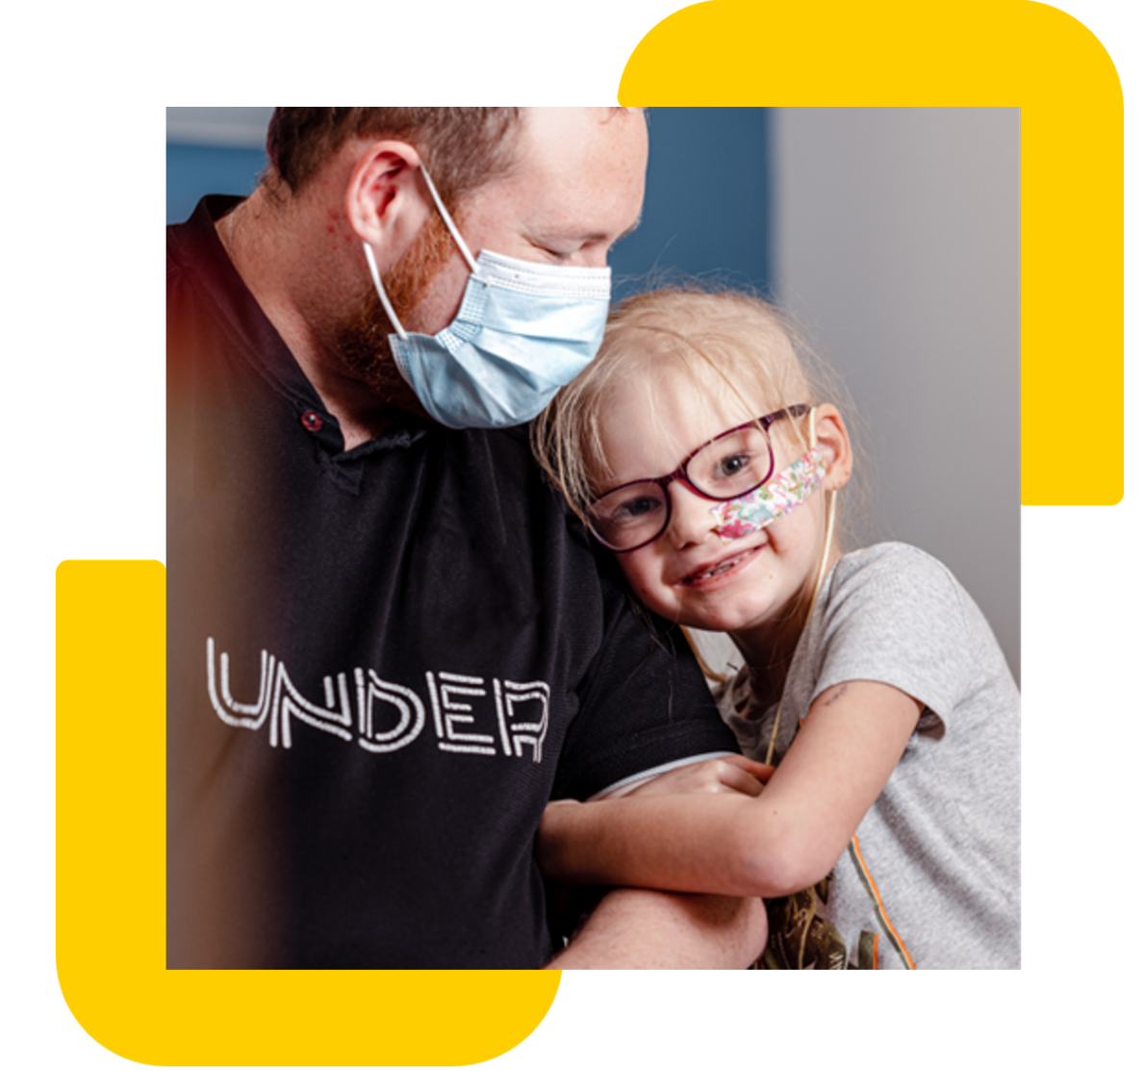

Registered Charity Number: 298405
Inaugurated by Diana, Princess of Wales
Company limited by guarantee, Number: 4960054

Job description

Job title: Junior Data Analyst
Contract: Full-time, Permanent
Location: Hybrid – Office 3 days a week (21-27 Lamb’s Conduit Street, London, WC1N 3NL)
Reporting to: Head of IT
Direct reports: None
Salary range: £26,000-£28,000 (based on experience)
Closing date: 14th May 2026

Role overview

We are seeking a motivated and detail-oriented Junior Data Analyst to join our IT and Data team. You will work with colleagues across fundraising, marketing, finance and services to understand reporting needs and turn them into trusted datasets, dashboards and insights that help us raise vital funds and demonstrate impact for children and young people affected by cancer. Using Salesforce and Tableau as core tools, you will:

Key Responsibilities
- Partner with teams across fundraising, marketing, finance and services to gather requirements and translate them into clear reporting and insight solutions.
- Build, maintain and optimise Tableau dashboards that track key charity metrics (e.g., income, supporter engagement, campaign performance and operational KPIs).
- Query, extract and analyse data from Salesforce (CRM) to produce accurate reporting for fundraising activity, supporter journeys and internal decision-making.
- Document data definitions, business logic and reporting standards so colleagues have a shared understanding of key measures and KPIs.
- Identify trends, anomalies and opportunities within datasets and communicate insights clearly to non-technical stakeholders, with sensitivity to our cause and supporters.
- Support data quality monitoring and data governance in Salesforce, helping maintain clean, reliable and compliant records in line with GDPR and organisational policies.

Children with Cancer UK

At Children with Cancer UK, our vision is a world where every child and young person survives cancer. Every day, 10 children are diagnosed with cancer in the UK, 2 terminally. Of the 8 who survive, 5 will suffer long-term effects of their treatment. We fund vital research and provide support to families affected by childhood cancer.

We are the leading childhood cancer charity in the UK, supporting families and childhood cancer research since 1988. Over the last 35 years, we've developed kinder treatments, improved public and scientific understanding of childhood cancer and raised over £300 million along with investing in over 200 research projects to help fight the injustice of cancer in children.
Person Specification
 | Essential | Desirable
Experience | - Experience or strong familiarity with Salesforce CRM (or similar), including reporting, views, and understanding data objects (e.g., contacts/supporters, donations, campaigns).  - Experience using Tableau (or similar BI tool) to build dashboards and data visualisations for a range of audiences. | - Salesforce Administrator, Salesforce Certified Associate (or willingness to work towards certification).  - Experience working with charity/fundraising data (e.g., appeals, events, regular giving, major donors) or supporter care reporting.
Skills & Abilities | - Solid understanding of data analysis principles, including data quality, validation and the ability to interpret and present findings clearly.  - Strong communication skills, able to translate complex data into clear insight for colleagues and stakeholders across the charity.  - Comfortable working with structured data using tools such as spreadsheets, data extracts and basic querying, with an understanding of confidentiality and appropriate data handling. | - Awareness of GDPR and data protection principles, and/or experience supporting data governance and consent management.  - Exposure to ETL/data integration tools and an interest in developing skills in data engineering and automation.
Other attributes | - High attention to detail, a problem-solving mindset and a proactive attitude to improving processes and data quality.  - Ability to manage multiple priorities and deliver to deadlines in a collaborative, mission-driven environment.

Please note: If you don’t match all our essential criteria but have other relevant experiences and skills, please do apply. We would love to hear from you.
Other information

At Children with Cancer UK we value diversity, and we are committed to creating an inclusive culture where everyone is able to be themselves and to reach their full potential. The statements are not intended to be construed as an exhaustive list of all duties, responsibilities and skills required for this position.

How to Apply
We operate an anonymised shortlisting process in line with our commitment to equality, diversity, and inclusion. Please submit your CV and cover letter.

If you require any reasonable adjustments during the application or interview process, please contact us at hr@childrenwithcancer.org.uk

You must be eligible to work in the UK to apply for this vacancy.

