

Children with Cancer UK
Candidate Pack

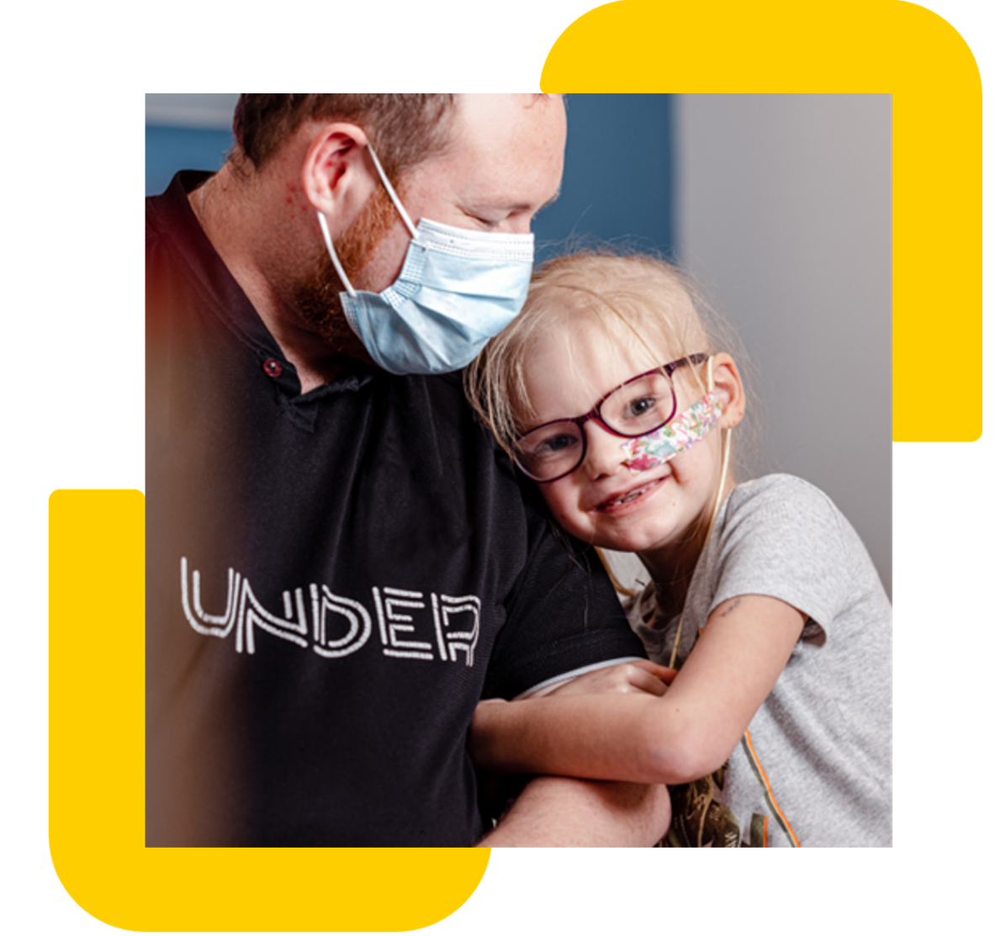

Registered Charity Number: 298405
Inaugurated by Diana, Princess of Wales
Company limited by guarantee, Number: 4960054

Job description

Job title: Salesforce Lead
Contract: Permanent
Location: Hybrid – Office 3 days a week (21-27 Lamb’s Conduit Street, London, WC1N 3NL)
Reporting to: Head of IT
Direct reports: None
Salary range: £45,000-£50,000 (based on experience)
Closing date: 14th May 2026

Role overview

The Salesforce Platform Lead is responsible for the administration, configuration, and optimisation of the Salesforce platform as a cloud-based CRM. The role focuses on platform configuration, governance, and adoption, ensuring Salesforce supports organisational strategic growth.

Children with Cancer UK

Children with Cancer UK is a leading children’s cancer charity dedicated to raising and investing funds into vital specialist research to save the lives of children with cancer. Our mission is to improve survival rates and the quality of survival in young cancer patients and to find ways to prevent cancer in the future. What began as a small memorial charity in 1988, has evolved into a major force raising more than £300 million and investing in over 200 research projects to help fight the injustice of cancer in children.

Main Responsibilities

1. Salesforce Lead

- Designing and governing automated, hands-off integrations using enterprise middleware, APIs, and advanced Salesforce integration patterns.
- Building complex, highly optimised Salesforce Flows (Record-Triggered, auto launched, Orchestration) that manage complex data filtration at source.
- Architecting the overarching data model across Sales Cloud, Data Cloud, and Marketing Cloud, including complex Identity Resolution and harmonisation rules.
- Configure Salesforce using declarative tools including objects, fields, page layouts, validation rules, flows, and permissions.
- Overseeing the deployment pipeline using industry-standard tools and methodologies to ensure all enhancements are audited, documented, and non-disruptive to the business.

2. Business Process Enablement

- Expertly translating complex business requirements into scalable Salesforce technical specifications, ensuring a balance between "out-of-the-box" functionality and custom scalability
- Re-engineering cross-functional workflows to maximise operational velocity, improve data integrity, and minimize friction in the user journey.
- Serving as the bridge between stakeholder vision and platform execution, ensuring Salesforce architecture remains a mirror of evolving organisational governance and business logic.
- Focused on process-centric enablement rather than passive data delivery, prioritising business outcomes, and long-term platform health over ad-hoc technical fixes.
- Serving as the bridge between stakeholder vision and platform execution, ensuring Salesforce architecture remains a mirror of evolving organisational governance and business logic.

3. Data Governance

- Architecting and enforcing rigorous data schemas and governance protocols within Salesforce to ensure cross-functional data consistency and "Single Source of Truth" (SSOT) integrity
- Designing sophisticated validation logic, triggers, and flow automation to intercept and remediate data quality issues at the source.
- Establishing and monitoring Key Performance Indicators (KPIs) for data health, utilising trend analysis to identify and pre-empt potential architectural drifts.
- Managing high-level technical escalations with IT partners and external vendors to resolve systemic synchronization or integration anomalies that impact data reliability.

4. Reporting & Dashboards

- Designing and maintaining sophisticated reporting suites and executive dashboards that translate raw data into actionable business intelligence and real-time performance tracking.
- Engineering intuitive, self-service reporting frameworks and training modules that empower departmental users to navigate complex data sets independently, reducing central.
- Partnering with key stakeholders to define and standardise High-Level KPIs and reporting taxonomies, ensuring cross-departmental alignment on critical business success metrics.
- Utilising Salesforce’s advanced reporting features, such as joined reports, historical trending, and cross-filters, to uncover underlying operational patterns and growth opportunities.

5. User Access & Platform Security

- Architecting and maintaining a robust security model utilising Profiles, Permission Sets, and Permission Set Groups to enforce the "Principle of Least Privilege" across a diverse user base.
- Aligning platform configurations with global data protection standards (such as GDPR or CCPA) and internal cybersecurity policies to mitigate unauthorised data exposure.
- Streamlining regulatory and internal audits by maintaining comprehensive Field-Level Security (FLS) documentation, login forensics, and system-wide security health checks.
- Overseeing the end-to-end user lifecycle, from automated provisioning to secure deactivation, ensuring organisational role hierarchies and sharing rules remain dynamic and secure.

6. Adoption, Training & Support

- Serving as the principal technical escalation point for complex functional challenges, diagnosing root causes, and implementing systemic long-term remediations.
- Providing high-level architectural guidance and strategic advisory to business units, ensuring that user behaviour aligns with optimal platform utilisation and industry standards.
- Driving organisational platform maturity through the design and delivery of high-impact enablement programs, comprehensive documentation, and iterative feedback loops.
- Orchestrating third-party training providers and technical consultants to ensure specialized knowledge transfer and the successful execution of large-scale educational initiatives.
7. Supplier & IT Collaboration

- Leading the evolution of the Salesforce environment by identifying and implementing high-impact platform improvements that bridge gaps between disparate business systems.
- Directing collaborative efforts with internal IT departments and external Salesforce consultancies to architect complex API integrations, platform enhancements, and systemic infrastructure upgrades.
- Serving as the Principal Stakeholder & Product Owner for all Salesforce-centric initiatives, ensuring technical roadmaps are perfectly synchronised with broader corporate objectives.
- Overseeing third-party deliverables to ensure all custom code, configurations, and integrations adhere to internal architectural standards and functional requirements.

Person Specification
 | Essential | Desirable
Experience | - Extensive background in orchestrating Salesforce ecosystems within complex, multi-layered organizational structures, ensuring cross-departmental synergy and system scalability.  - A proven track record of acting as a strategic liaison, translating executive vision into technical roadmaps and maintaining rigorous documentation standards for institutional knowledge.
Skills & Abilities | - Advanced proficiency in Salesforce Flow, Dynamic Forms, and complex validation logic, leveraging declarative tools to build sophisticated, high-performance business solutions.  - Deep-domain expertise in end-to-end CRM lifecycles, specialising in the alignment of technical architecture with nuanced commercial and operational workflows. | - Possession of Salesforce Certified Administrator and Advanced, demonstrating a deep technical mastery of the platform’s architectural capabilities and governance best practices.  - Expertise in designing high-touch Customer Relationship Management (CRM) frameworks that drive engagement, retention, and personalized user journeys.
Other attributes | - A comprehensive understanding of data privacy frameworks and regulatory compliance, ensuring platform security and data integrity meet enterprise-grade standards.

Please note: If you don’t match all our essential criteria but have other relevant experiences and skills, please do apply. We would love to hear from you.
Other information

At Children with Cancer UK we value diversity, and we are committed to creating an inclusive culture where everyone is able to be themselves and to reach their full potential. The statements are not intended to be construed as an exhaustive list of all duties, responsibilities and skills required for this position.

How to Apply
We operate an anonymised shortlisting process in line with our commitment to equality, diversity, and inclusion. Please submit your CV and cover letter.

If you require any reasonable adjustments during the application or interview process, please contact us at hr@childrenwithcancer.org.uk

You must be eligible to work in the UK to apply for this vacancy.

