

Children with Cancer UK
Candidate Pack

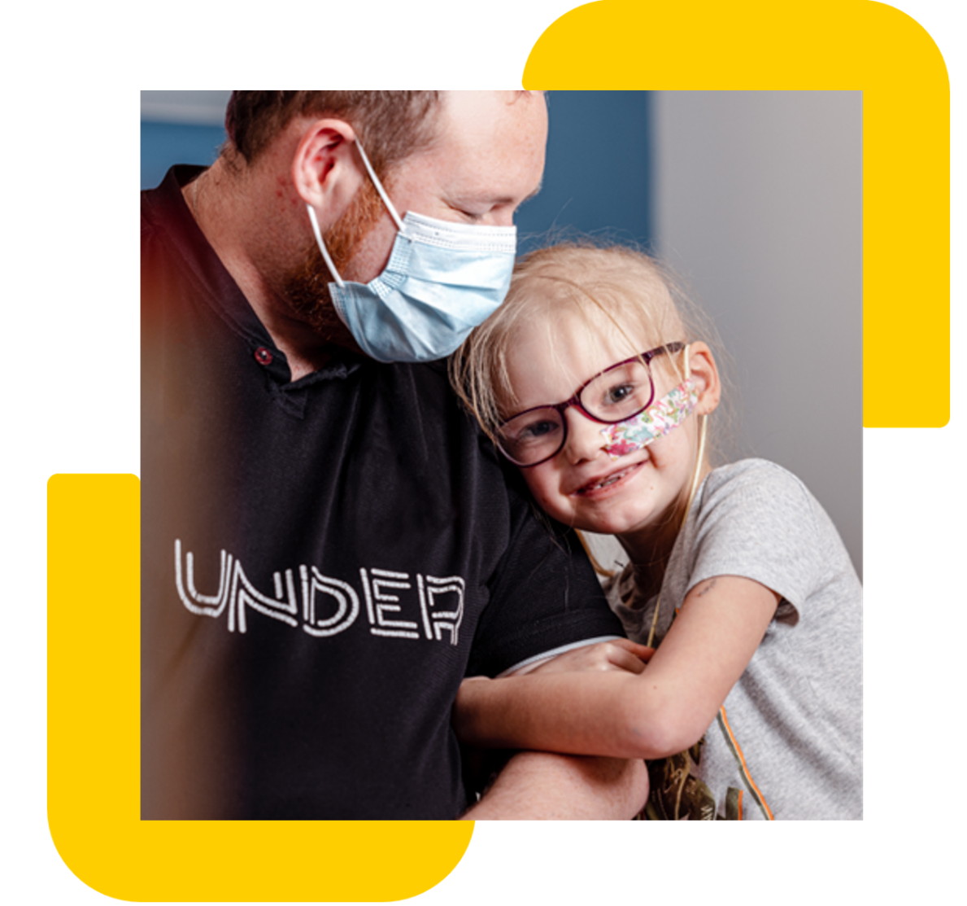

Registered Charity Number: 298405
Inaugurated by Diana, Princess of Wales
Company limited by guarantee, Number: 4960054

Job description

Job title: Data Analyst
Contract: Full time
Location: Hybrid – Office 3 days a week (21-27 Lamb’s Conduit Street, London, WC1N 3NL)
Reporting to: Head of IT
Direct reports: None
Salary range: £30,000-£32,000 (based on experience)
Closing date: 18th of August 2026

Children with Cancer UK

Children with Cancer UK is a leading children’s cancer charity dedicated to raising and investing funds into vital specialist research to save the lives of children with cancer. Our mission is to improve survival rates and the quality of survival in young cancer patients and to find ways to prevent cancer in the future. What began as a small memorial charity in 1988, has evolved into a major force raising more than £300 million and investing in over 200 research projects to help fight the injustice of cancer in children.
Role overview

We are seeking a motivated and detail-oriented Data Analyst to join our IT and Data team. You will work with colleagues across fundraising, marketing, finance and services to understand reporting needs and turn them into trusted datasets, dashboards and insights that help us raise vital funds and demonstrate impact for children and young people affected by cancer. Using Salesforce and Tableau as core tools, you will;

Main Responsibilities

- Partner with teams across fundraising, marketing, finance and services to gather requirements and translate them into clear reporting and insight solutions.
- Build, maintain and optimise Tableau dashboards that track key charity metrics (e.g., income, supporter engagement, campaign performance and operational KPIs).
- Query, extract and analyse data from Salesforce (CRM) to produce accurate reporting for fundraising activity, supporter journeys and internal decision-making.
- Document data definitions, business logic and reporting standards so colleagues have a shared understanding of key measures and KPIs.
- Identify trends, anomalies and opportunities within datasets and communicate insights clearly to non-technical stakeholders, with sensitivity to our cause and supporters.
- Support data quality monitoring and data governance in Salesforce, helping maintain clean, reliable and compliant records in line with GDPR and organisational policies.

Required Skills & Experience
- Experience or strong familiarity with Salesforce CRM (or similar), including reporting, views, and understanding data objects (e.g., contacts/supporters, donations, campaigns).
- Experience using Tableau (or similar BI tool) to build dashboards and data visualisations for a range of audiences.
- Solid understanding of data analysis principles, including data quality, validation and the ability to interpret and present findings clearly.
- Strong communication skills, able to translate complex data into clear insight for colleagues and stakeholders across the charity.
- Comfortable working with structured data using tools such as spreadsheets, data extracts and basic querying, with an understanding of confidentiality and appropriate data handling.
- High attention to detail, a problem-solving mindset and a proactive attitude to improving processes and data quality.
- Ability to manage multiple priorities and deliver to deadlines in a collaborative, mission-driven environment.
Desirable
- Salesforce Administrator, Salesforce Certified Associate (or willingness to work towards certification).
- Experience working with charity/fundraising data (e.g., appeals, events, regular giving, major donors) or supporter care reporting.
- Awareness of GDPR and data protection principles, and/or experience supporting data governance and consent management.
- Exposure to ETL/data integration tools and an interest in developing skills in data engineering and automation.

Please note: If you don’t match all our essential criteria but have other relevant experiences and skills, please do apply. We would love to hear from you.
Other information

At Children with Cancer UK we value diversity, and we are committed to creating an inclusive culture where everyone is able to be themselves and to reach their full potential. The statements are not intended to be construed as an exhaustive list of all duties, responsibilities and skills required for this position.

How to Apply

Please submit your CV and cover letter as one document e.g. PDF or Word document.

Applications should represent the candidate’s own experience and perspective. While AI tools may be used for guidance, responses must reflect your personal experience and may be discussed in detail during the selection process.

If you require any reasonable adjustments during the application or interview process, please contact us at hr@childrenwithcancer.org.uk

You must be eligible to work in the UK to apply for this vacancy.

